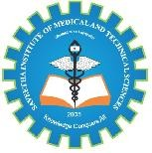 SIMATS ENGINEERING 
Saveetha Institute of Medical and Technical Sciences
Chennai- 602105
Student Name: S. Susithra
Reg. No.: 1912260033
Course Code: BTA0101
Slot: C
Course Name: Biology and Environmental Sciences for Engineers
Course Faculty: Dr. D. Swathi
Project Title: “Protein-Based Hydrogels: Designing Hydrogels from Proteins for Medical Applications”
Module Photographs: 1st Review geo tag photo, 2nd Review geo tag photo, Model photo
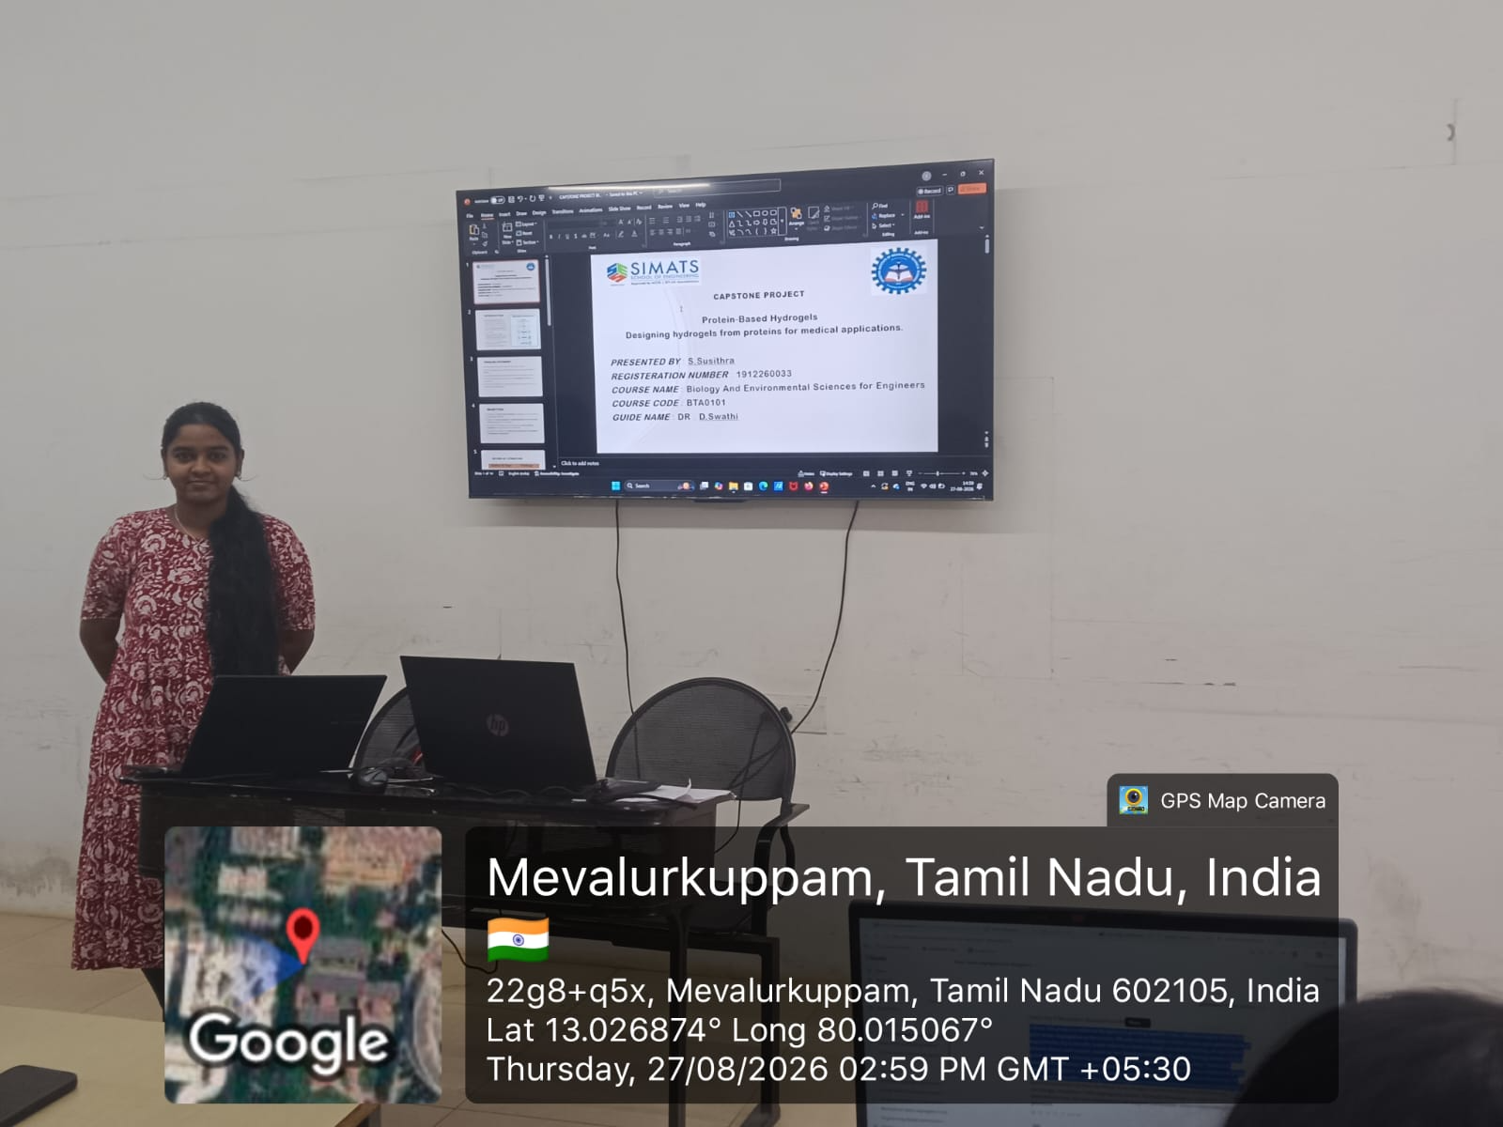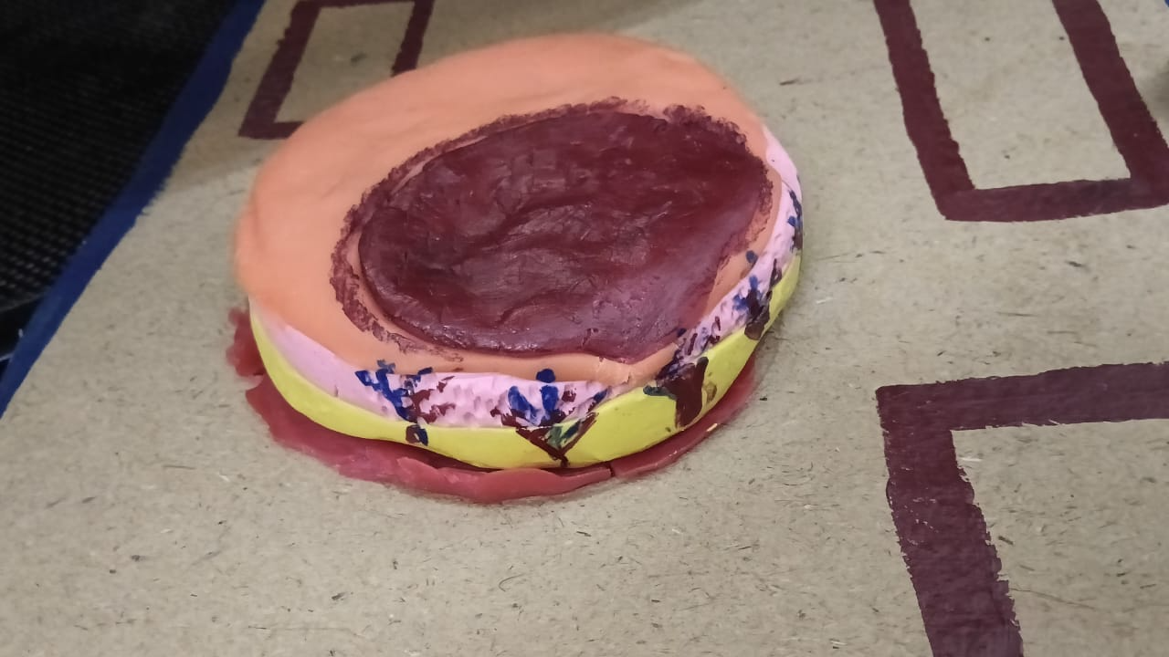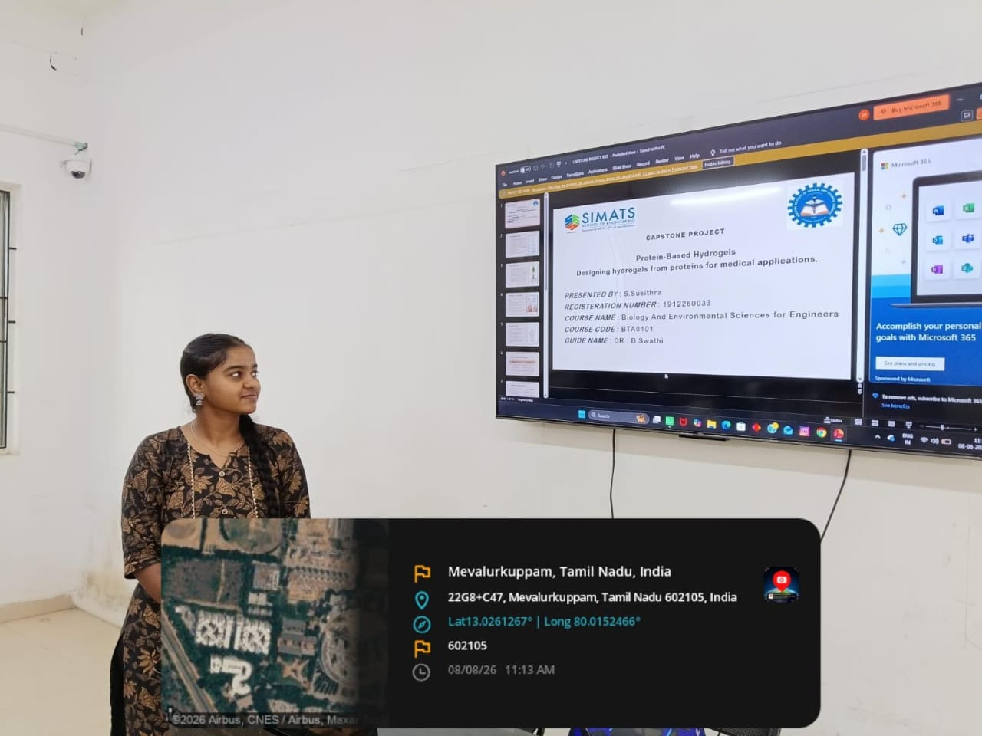
Project Description: This project focuses on developing a low-cost hydrogel for wound-dressing applications.
Agar-agar is used as a natural gelling agent to form the hydrogel structure.
The hydrogel contains a high amount of water, helping maintain moisture.
It forms a soft and flexible three-dimensional network.
The material is simple and economical to prepare.
It can demonstrate moisture retention and absorption properties.
The hydrogel may provide a suitable environment for wound healing.
The project highlights the use of natural materials in biomedical applications.
It also promotes an affordable and sustainable approach to wound dressing.
Overall, the project demonstrates the potential of hydrogel-based wound care.
Student Signature Guide Signature

